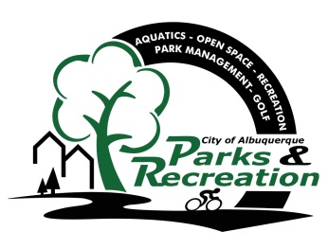
Greater Albuquerque
Recreational Trails Committee

Meeting Agenda

Tuesday, October 18, 2016
3:30 p.m. - 5:30 p.m.
Meeting Place: 7th Floor conference room, Room 7096
City Hall, Fifth and Marquette, NW

- Welcome and Introductions
- Approval of October 18, 2016 Agenda
- Approval of September 20, 2016 Minutes
- General Announcements

- New Business/Presentations

Petroglyph National Monument Visitor Use Plan-Diane Souder, NPS

•1 Discussion/Action Items/Ongoing Business –

- Committee Member Recruitment………………………………………………………………………GARTC
- Tramway Trail Invasive Species and Landscaping…………………………………………………..GARTC

- Staff Reports and Project Updates

- Public Comment
(Must be requested 24 hours prior to scheduled meeting, please email jcoffey@cabq.gov (Public input is limited
to 2 Minutes)

•2 Adjourn

- Next GARTC meeting November 15, 2016

Members:
Vacant – East At Large Representative; Ian Maddieson (Chair) - Pedestrians and Hikers; Valerie Cole – Equestrians; Warren Wild - Off-Road Bicyclists (Mountain Bicyclists); Ron Cossey – Runners and Joggers; Tyler Ashton (Vice Chair) – West At Large Representative; Kathleen Rhoad – Active Elderly; Vacant − Physically Challenged

GARTC Members: If you will not be able to attend the meeting, please call Jason Coffey at 768-5325 or email at jcoffey@cabq.gov

Staff: City – Jason Coffey – PRD, 768-5325

NOTICE TO PERSONS WITH DISABILITIES: If you have a disability and require special assistance to participate in this meeting, please contact the office at least 4 days prior to the meeting at 768-5325 (voice), or by TTY at New Mexico Relay, 1-800-659-8331.

